PESTLE WEED COLLEGE OF INFORMATION TECHNOLOGY, DEHRADUN (DEPTT. OF EDUCATION)

DETAILS OF QUALIFICATIONS AND EXPERIENCE OF FACULTY FOR SESSION (2022-23)

Sr.  No. | Name of the staff & Designation | Qualifications |  |  |  | Experience |  | Photograph |  | Salary (Rs.) | D.O.J
Sr.  No. | Name of the staff & Designation | B.Ed.  (with % ) | M.Ed.  (with %) | PG  (Subject) % | NET/SLET/ Ph.D.  (Subject with %) | Teacher  Training College | School
(Principal/HOD)
1. | Dr. (Mrs.) Nisha Rani | 67.1% | 71.3% | M.A.  (Sociology) 65.3% | Ph.D. Education NET, M.Phil.  (Edu.) | 14 years | 02 years | 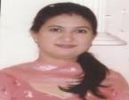 |  | 52,500/- | 10.07.17
(Associate/Assistant Professor)
2. | Dr. (Mrs.) Shobha Rani Sabharwal | 66.4% | M.Ed.-58% | M.A. (Psy.) 64.8% M.A.  (Pol. Sc.) 57% | Ph.D. (Education) NET | 13 years | 08 years | 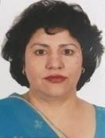 |  | 32,720/- | 05.01.07
3. | Dr. (Mrs.) Ritu Gairola | 63% | M.Ed.-70% | M.Sc. Maths 63.3% | Ph.D. (Education) NET | 08 years | -- |  | 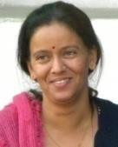 | 24,720 /- | 23.01.09
4. | Dr. (Mrs.) Shailja Srivastava | 56 % | M.A.  (Education)- 69%  M.Ed.-52.8% | M.A. (Hindi)  -57% M.A.  (Sociology)  - 54% | Ph.D. (Education) M.Phil (Education) | 14 years | 05 years |  | 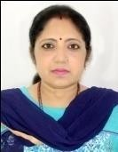 | 28,420/- | 07.08.09
5. | Dr. Kalpana Singh  (Fine Art) | -- | -- | M.A.  (Painting)- 59.8% | Ph.D. (Arts) | 04 years | -- |  | 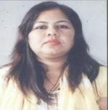 | 21,023/- | 10.08.15
6. | Mrs. Mala Sharma | 72.70% | M.Ed. 68.1% | M.Sc.  (Chemistry) 62.6% | -- | 09 years | -- |  |  | 26,250/- | 12.03.10

7. | Ms. Ruchi Baloni | 78% | M.Ed. 66.5% | M.Sc.  (Botany) 62% | -- | 02 years | 01year | 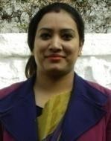 | 21,410/- | 14.09.16
8. | Ms. Shaifali Bahl | 78.2 % | 61 % | M.Com. 55.4 % | M.Phil. 59 % | 08 yrs | 08 yrs. | 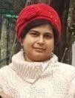 | 26,670/- | 05.01.07
9. | Mr. Satish Purohit | 66.6 % | 67.5 % | M.Sc. Physics  57.7 % | -- | 7 Years | 07 yrs. | 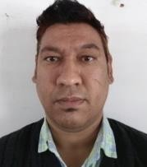 | 23,150/- | 06.04.11
10. | Ms. Richa Dobhal | 75.25% | M.Ed.- 70.33% | M.Sc.  (Physics)- 65.7% | Ph.D. (Pursuing) | 6 years | -- | 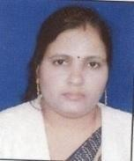 | 21,410/- | 17.05.17
11. | Mrs. Samta Gupta  (Performing Art) | -- | -- | M.A.  (Painting)-59% M.A.  (Prabhakar)- 65% | -- | 02 years | 15 yrs | 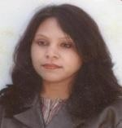 | 34,310/- | 06.05.17

12. | Dr. Abdul Qadir (Visiting faculty) | 60% | -- | M.Sc.  (Biotechno logy) 67% | Ph.D.  (Biotech) | 07 years | 07 years | 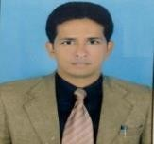 | 35,000/- | 20.11.18
13. | Km. Saroj Bisht | 69 % | M.Ed. 65.1% | M.A.  (English)  63.8 % | UTET, CTET | 01 yrs | 01 yrs |  | 16,800/- | 08.02.19
14. | Ms. Garima Negi | 67.6% | M.Ed. 63.8% | M.Sc.  Zoology 68.8% | -- | -- | -- | 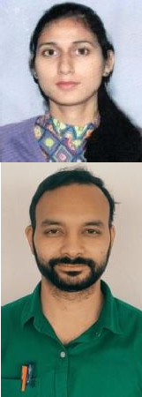 | 17,850/- | 01.09.19
15. | Mr.Prateek Negi | 72% | -- | M.A.  (Geography) 74.75% | NET (Geography) | 01 year 01 month | - |  | 18,000/- | 16-02-2021
16. | Mr. Shubham Raturi | 80.2% | M.A.  (Education) (pursuing) | M.Sc.  ( Chemistry) 77.1% | CTET | -- | -- |  | 16,000/- | 02-03-2021
17. | Mr. Krishna Negi | B.Ed. 76% | M.Ed.  79% | M.A Political Science 70% | UGC- NET (Education) | 02 Year | -- | 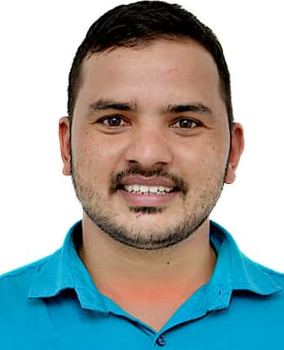 | 16,000/- | 01.12.21
18. | Mr. Gaurav Khanduri | 70.5% | M.A. (Edu.)- Pursuing | M.Sc. (Botany)-72% | -- | 1 year 7 months | -- |  | 16,000/- | 26.11.2021
19. | Mrs. Anita Vijan | 69% | 77% | M.Sc. (Chemistry)- 60% | - | 24.4 years | -- |  | 36,000/- | 20.11.18
20. | Mr. Dharmendra Singh | B.Ed. 73% | M.A. Education  62% | M.A Hindi  66.6% | UGC-NET (Hindi) | 2 year 2 months |  | 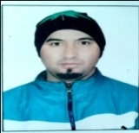 | 18,000/- | 05.06.21
21. | Mr. Sandeep Singh | 73% | M.A. (Education)- Pursuing | M.Sc. (Maths)- 78% | -- | 1 year 11 months |  |  | 18,000/- | 17.09.21
22. | Mrs. Deepti Varshney | B.Ed- 67.5% | M.Ed.- 74% | M.A English 74%  M.A Social Work 60% | UGC-NET (Education)  UGC-NET (Social Work) | 2.5 yrs |  | 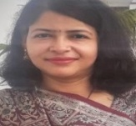 | 19,000/- | 01.10.21
23. | Dr. Sarika Mittal | 78% | M.Ed. 68% | M.A. (Economics) - 61% | Ph.D (Education), NET, USET | 09 yrs |  | 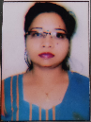 | 22,780/- | 05.02.20

(Details of Faculty Left the Institution during the last quarter ) D.O.J. D.O.L
1. | Mrs. Rekha Dhyani | 76.1 % | M.Ed. 63.3% | M.Sc.  (Maths)  65.1 % | NET (Education), Ph.D (Education) | 02 Yrs | -- | 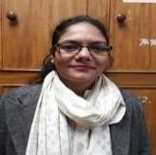 | 02.09.19 | 20.04.2021
2. | Ms. Yogita Rana | 71.3% | M.Ed.- 73.6% | M.A.  English literature - 60.2% | Ph.D. (Pursuing), UTET | 02 years | 02 years | 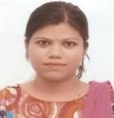 | 08.05.17 | 19.08.2021
3. | Dr. Mamta Sakta | 67% | M.A.  Education  -70% M.Ed. 64.5% | M A..  (Philosophy) 55%  M.A. (Hindi)- 57% | Ph.D. (Education), M.Phil. | 08 years | -- | 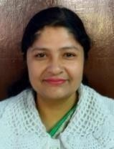 | 14.09.2016 | 25.04.2021
4. | Mr. Rajesh | 61 % | -- | M.A  (Geograph y) 60% | NET  (Geography) | -- | --. | 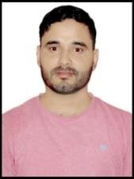 | 11.12.19 | 09.02.21
5. | Mrs. Divya Aggarwal | Th.-82% Pr.- 87% | M.Ed.- 73.83% | M.Sc.  (Physics)-65 % | UTET | 06 years | -- | 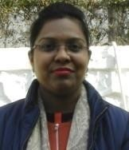 | 15.09.16 | 28.03.22

PESTLE WEED COLLEGE OF INFORMATION TECHNOLOGY, DEHRADUN (DEPTT. OF EDUCATION)
DETAILS OF ADMINISTRATIVE & PROFESSIONAL SUPPORT STAFF

S.No. | Name | Designation | Qualifications
1. | Mr. P. Noel | Chief Admin. Officer | M.Com.
2. | Mrs. Shikha Rawat | Librarian | B.A., M. Lib.
3. | Mrs. Smita Tiwari | Accountant | B.A., Diploma in Financial Management
4. | Mr. S.B. Thapa | Office Superintendent cum Store In-charge | Intermediate  Retd. Honorary Captain from Indian Army
5. | Mrs. Vijaya Sethi | PA to Principal | M.A. English, Diploma in  Computers
6. | Mr. Bhupal Singh Adhikari | Estate Supervisor cum Technical Assistant | B.A.
7. | Mrs. Maya Devi | Lab Attendant/  Aaya | Metric
8. | Mr. Manoj Bhatt | Lab Attendant/ Peon | Metric
9. | Mr. Jitendra Singh | Driver | Metric
10. | Mr. Roop Ram | Mali | -
11. | Mr. Kundan Singh | Security Guard | VIII
12. | Mr. Naveen Kumar | General Duty | VIII

