Importance of Economic Zoology

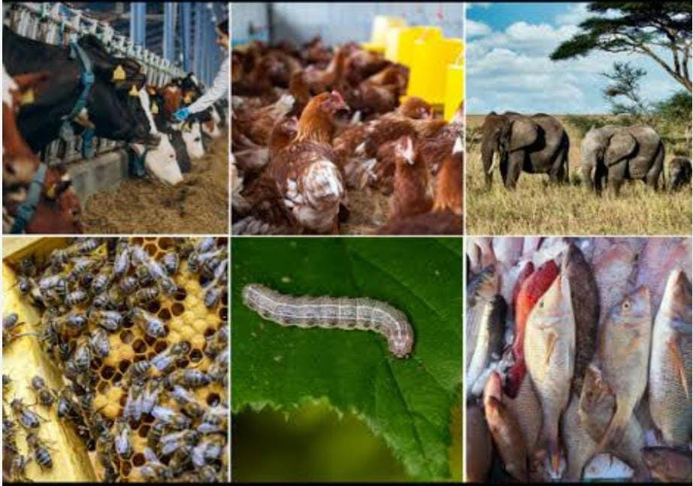

Economic zoology is the study of animals in relation to their economic value and impact on human activities. Its importance can be summarized in several key areas:

Agriculture: Understanding animal behavior and physiology helps improve livestock management, leading to enhanced productivity and food security.

Biodiversity Conservation: Economic zoology informs conservation efforts by identifying species that are crucial for ecosystems and human economies.

Pest Control: Knowledge of animal interactions can lead to effective pest management strategies, minimizing crop damage and reducing reliance on chemical pesticides.

Medicine: Many animals are sources of pharmaceuticals, and studying their biology can lead to the discovery of new drugs and treatments.

Ecotourism: Promoting sustainable use of animal resources supports tourism and local economies while encouraging conservation.

Fisheries: Understanding aquatic species and their ecosystems helps manage fish populations sustainably, ensuring long-term food supply and economic viability.

Overall, economic zoology plays a vital role in promoting sustainable practices, enhancing food production, and conserving biodiversity while supporting economic growth.

Mrs. Garima Negi,
Assistant Professor of Zoology, PWCIT

